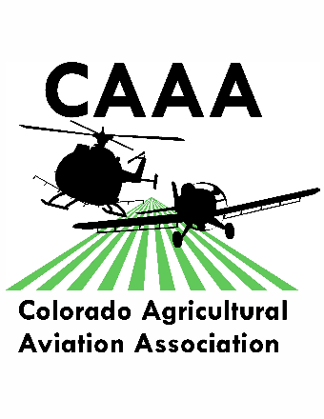**Colorado Agricultural Aviation Association**

**Trade Show Allied (Vendor) Registration Form**

October 15-17, 2019

Doubletree by Hilton

919 7th St.

Greeley, CO 80634 1-800-222-TREE

Room rate is $119+ tax/ night

Group reference code for Co. Ag Aviation: AGR

Contact Person: _____________________________________________________________

Company Name: _____________________________________________________________

Address: ____________________________________________________________________

City: _______________________________ State: _________________Zip: _____________

Phone: _______________________Fax:_________________ Email: __________________

Attendee Names: __________________________ __________________________

__________________________ __________________________

_____ **Booth Fee** $500 _______

(includes registration fee & meals for one registrant) meals provided are breakfast daily, lunch Tues & Weds, Dinner on Tuesday evening

______ Electricity Needed for booth _____ **Additional Personnel Registration** (per person) $200 _______

_____Additional Luncheon meal on Tuesday Oct. 15 2019 $30 _______

_____Additional Banquet Tickets (Tuesday evening) $45 _______

_____Meal Sponsorship (whole) $3000 (half) $1500 _______

_____Open bar sponsorship (whole) $2000 (half) $1000 _______

_____Coffee break/soda break sponsorship (whole) $500 (half) $250 _______

_____**Scholarship sponsorship** (Any amount) _______

_____Sponsorship (for any other amount for event) $100, $250, $500 _______

Total: $ _______________

Questions? Call Jessica Freeman at (970)217-5293 or (719) 362-0743

**Please mail completed registration & payment to: CoAAA attn: Jessica Freeman 16489 Burghley Ct. Platteville, CO 80651 or email to** [**jessica@coagav.org**](mailto:jessica@coagav.org)

Payment option: Check Amount $_______________ Check #___________________

Credit Card Visa, MasterCard, American Express or Discover accepted

Card Number: - - - CVV Code (3 digit) ____________

Name on Card: _________________________ Expiration: _____________ Billing ZIP _____________

Amount authorized to charge: $ ___________ Signature: ________________________