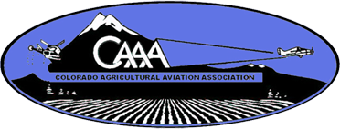
Colorado Agricultural Aviation Association
2022 Sponsorship Form
*please email company logo to jessica@coagav.org
September 26, 2022
Southeast Colorado Regional Airport Lamar, CO (KLAA)
3670 County Road Gg. 2, Lamar, CO 81052

ALL MEMBERS AND SPONSORS ARE WELCOME TO ATTEND THE EVENT ON ONE OR BOTH DAYS

Contact Person: _____________________________________________________________________________
Company Name: ____________________________________________________________________________
Address: ___________________________________________________________________________________
City: _______________________________ State: _________________Zip: _____________________________
Phone: _______________________ Fax:_________________ Email: ___________________________________
2022 Fly-in September 26, 2022
____ General Sponsorship $_________________
____ Meal Sponsorship $_________________
Total: $ _______________
Questions? Call Jessica Freeman at (970) 217-5293 or (719) 362-0743
Please mail completed registration & payment to: C0AAA 16489 Burghley Ct. Platteville, CO 80651

Payment Options: Check Amount $____________________ Check #_________________________

Credit Card: Visa MasterCard, American Express, or Discover Accepted

Card Number __________-___________-___________-___________ Expiration Date:___________________

CVV Code (on back of card) __________ Zip Code (card billing address Zip) ___________________________

Name on the Card__________________________________________________________________________

Signature of Card Holder:______________________________________________________________________

